Unlocking Insights into the Global Air Transportations Network with Tableau

SUBMITTED BY

1. MOHANA G (Team Leader) C3E6751307E90469AC54DB7BDCA4F717
2. SWETHA E

917F583876CD1779AB9438155AC57244

1. LALITHA S

F6448318A9565A6BE6947AAA0D345065

GUIDED BY

DR.D. ARUMUGAKAN

(Assistant Professor)

DEPARTMENT OF MATHEMATICS

SRI MEENAKSHI GOVERNMENT ART COLLEGE FOR WOMEN (A) MADURAI-625002



1. INTRODUCTION:

1.1 Overview

Unlocking insights into the global air transportation network using tableau involves leveraging data visualization and analytics tools gain a better understanding of the complex and interconnected world of aviation.

Tableau is a powerful Data visualization software that can help analyse and represent data related to air travel in a user-friendly and insightful manner.

By integrating various Data sources, such as flight schedule, Passenger Demographics, Cargo data, and airport information, into Tableau, You can create interactive Dashboards and Reports that allow you to:

Visualize flight routes: Plot flight paths and destinations to understand global connectivity and Transportation hubs.

Analyse Passenger trends: Examine passenger demographics, Booking patterns, and preferences to optimize marketing and operations.

1.2 PURPOSE:

Use:

If this is a collaborative project, Provide documentation or training to help Users make the most of your Tableau Dashboards.

Determine how users will interact with the data. Incorporate filters, parameters, and actions to allow users to explore the data on their at terms.

2. PROBLEM DEFINITION & DESIGN THINKING

2.1 Empathy:

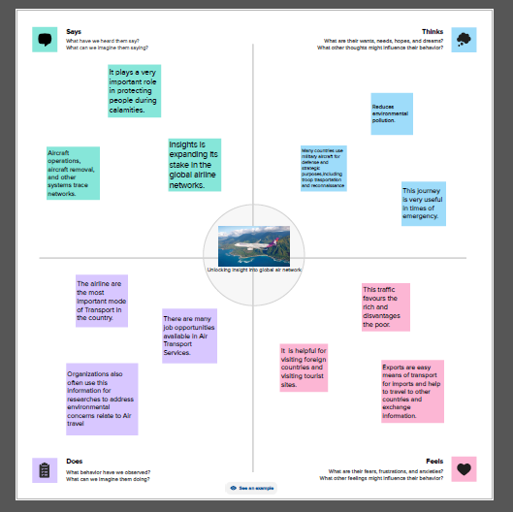

2.2 IDEATION & BRAINSTORMING MAP

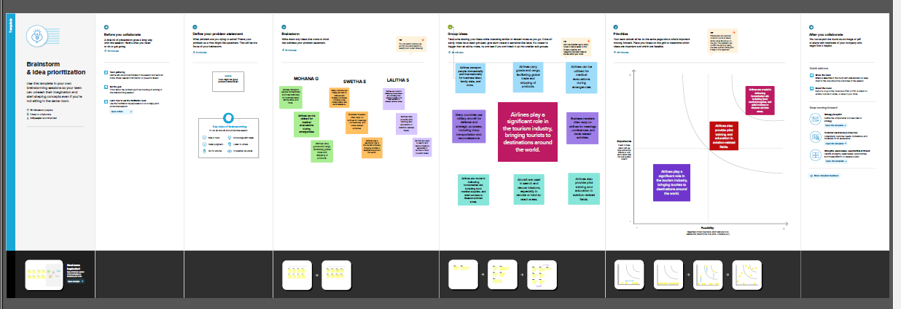3. RESULT

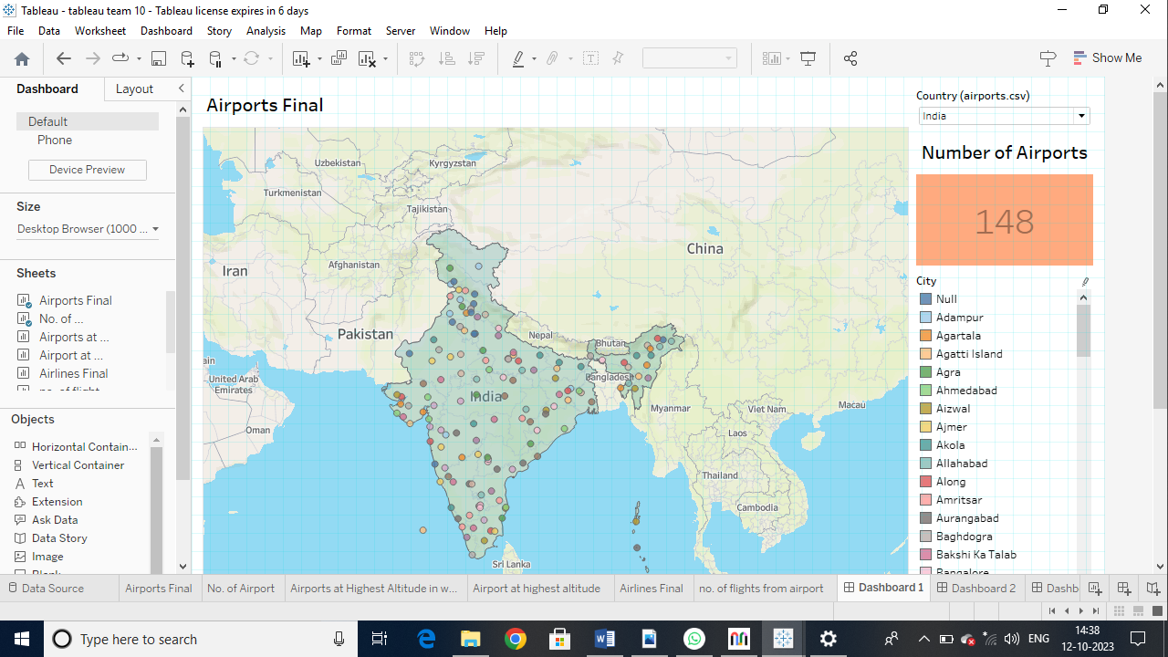

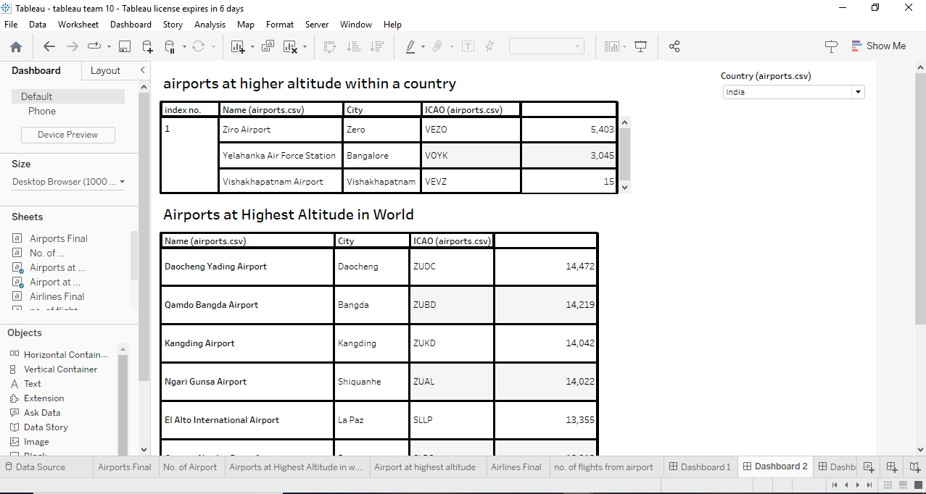

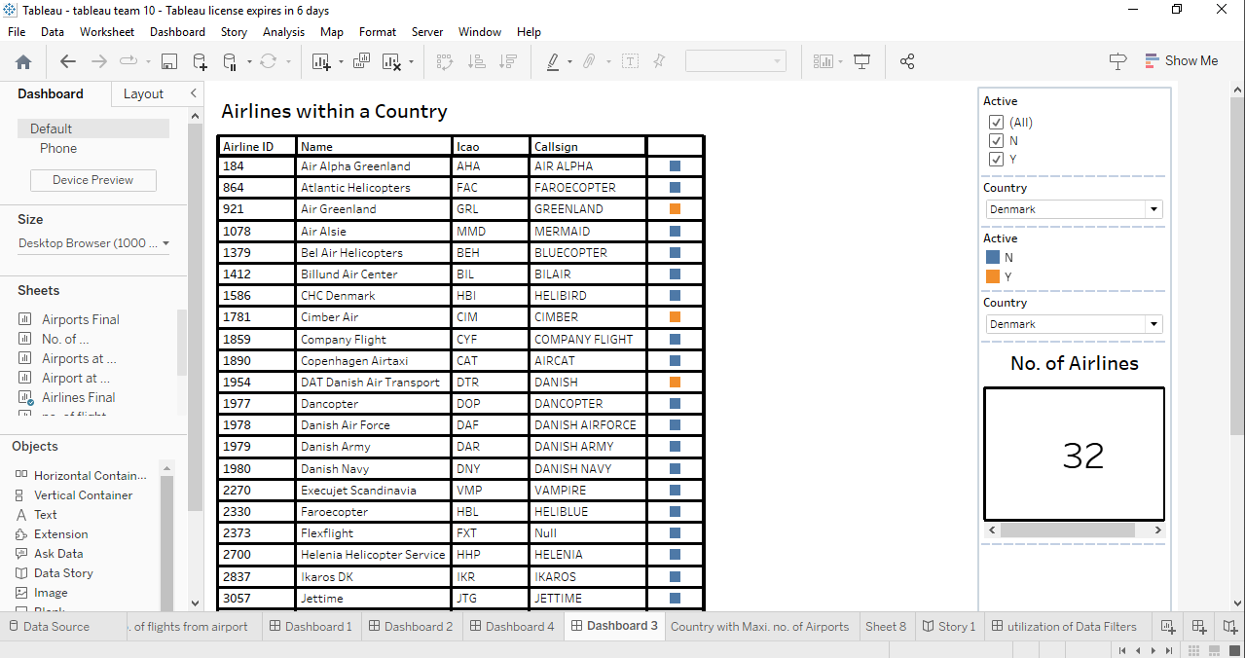

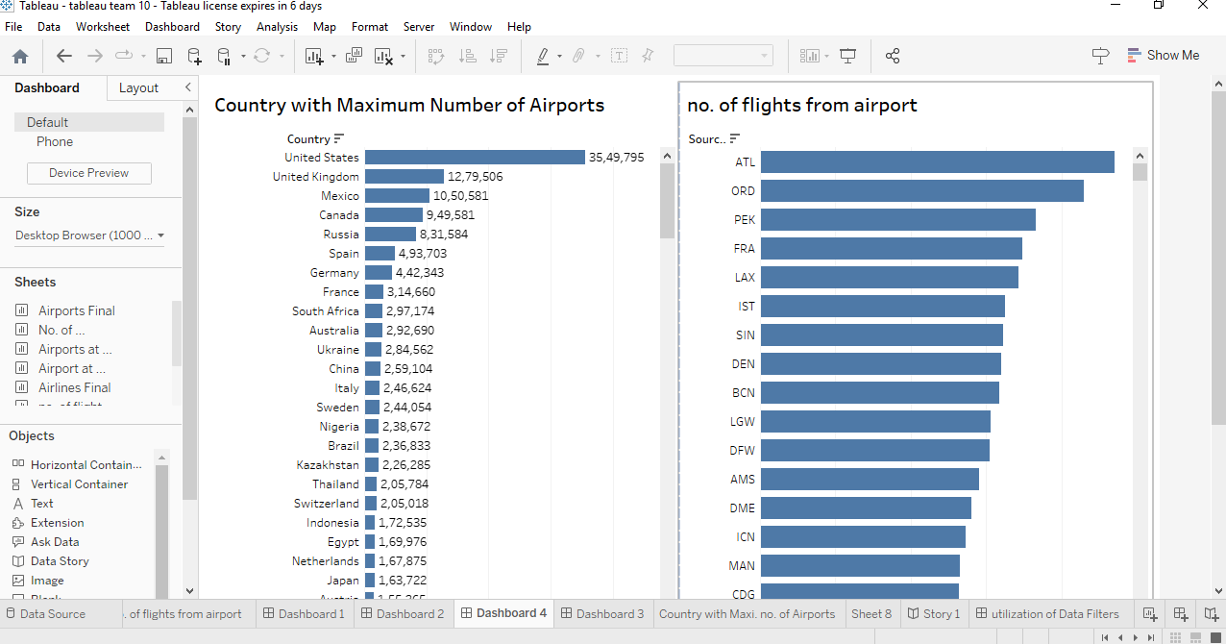

4. ADVANTAGES & DISADVANTAGES

Advantages:

1. Tableau excels in creating interactive and visually appealing data visualizations. You can create charts, graphs, maps, and dashboards to represent data related to global air transportation, making it easier to identify patterns and trends.

2. Tableau offers a user-friendly interface that allows users with various levels of expertise to work with data. You don't need to be a coding expert to create meaningful visualizations.

3. Tableau can connect to a wide range of data sources, including databases, spreadsheets, and cloud-based services. This means you can easily gather and integrate data from various sources in the air transportation industry.

4. You can build interactive dashboards that enable users to explore data and gain insights. This is valuable when analyzing complex networks like the global air transportation system.

5. Tableau supports real-time data connections, which is crucial for monitoring and analyzing the ever-changing air transportation network.

Disadvantages:

1. Tableau can be expensive, especially for larger organizations or extensive data projects. Licensing and subscription costs may be a limiting factor for some users.

2. While Tableau is user-friendly, mastering its advanced features and functionalities can take time. Training and practice are often required.

3. When working with very large datasets, Tableau's performance can be an issue. It may require a robust infrastructure to handle extensive data.

4. Data preparation capabilities in Tableau are not as robust as dedicated data preparation tools. For complex data cleaning and transformation, you may need to use additional software.

5. While Tableau offers a wide range of visualization options, some advanced customizations may be limited. In cases where highly specialized visualizations are required, you might need to resort to other tools.

5. APPLICATIONS:

Tableau is a powerful data visualization and analytics tool that can be applied across various aspects of the global air transportation network. It can be used for operational efficiency, route planning, passenger experience, safety and compliance, environmental impact, crisis management, market analysis, maintenance and reliability, regulatory compliance, forecasting, financial performance, air cargo and logistics, urban air mobility (UAM), and academic and research use. By analyzing historical flight data, passenger demand, and geographical factors, Tableau helps optimize flight routes, reduce fuel costs, and improve passenger experience. It also aids in reducing environmental impact, managing crises, and predicting passenger demand and fuel prices. The tool's applications are wide-ranging, catering to the diverse needs of airlines, airports, regulatory bodies, passengers, and industry researchers.

6. CONCLUSION:

Tableau is a transformative tool for the global air transportation industry, offering data-driven decision-making, operational efficiency, customer insights, safety and compliance, environmental sustainability, predictive analytics, and technology integration. It allows airlines, airports, and regulatory bodies to visualize complex data sets, uncover patterns, and make informed choices to enhance operations, safety, and customer satisfaction. Tableau's real-time data analysis and visualization capabilities optimize processes, reduce delays, and improve efficiency. It also allows airlines to tailor services to meet customer expectations, ensure regulatory compliance, and measure environmental impact. As technology advances, the integration of AI, machine learning, augmented reality, and virtual reality with Tableau will further enhance analysis and decision support.

7. FUTURE SCOPE:

Tableau is poised to revolutionize the global air transportation network, offering insights that will evolve with technological advancements and the evolving aviation industry. Future trends include predictive analytics, AI and machine learning integration, real-time insights, environmental sustainability, integration with aviation data sources, cybersecurity and data protection, augmented reality and virtual reality, blockchain for data transparency, data sharing and collaboration, regulatory compliance, personalized passenger services, and urban air mobility (UAM). These technologies will enable airlines to forecast passenger demand, predict delays, and personalize experiences. Tableau will also integrate with aviation-specific data sources, ensuring data transparency and integrity. It will also be used for data sharing and collaboration, ensuring regulatory compliance, creating personalized passenger services, and adapting to emerging transportation modes like eVTOL aircraft. As the aviation industry becomes more data-driven and interconnected, Tableau will continue to play a crucial role in extracting valuable insights.